20/21

DAW2

KHADY CISSE

PLANTILLA

DINT

Tabla de contenido

[Tema\_1 2](#_Toc51602846)

[Plantilla documento Word 2](#_Toc51602847)

# Tema\_1

## Plantilla documento Word

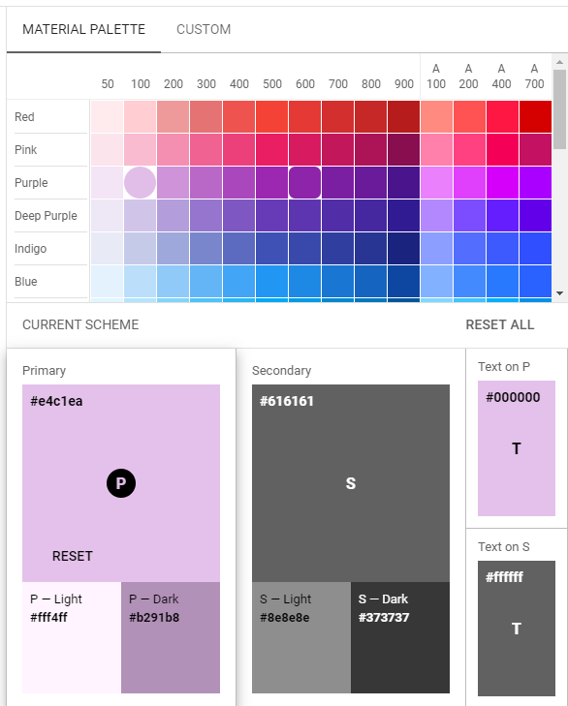

|  |  |
| --- | --- |
| C:\Users\DAW2\Dropbox\Mi PC (PC01)\Documents\CLASES\DINT\Temas\Tema_1\Practicas\foto5.png | C:\Users\DAW2\Dropbox\Mi PC (PC01)\Documents\CLASES\DINT\Temas\Tema_1\Practicas\foto6.png |
| C:\Users\DAW2\Dropbox\Mi PC (PC01)\Documents\CLASES\DINT\Temas\Tema_1\Practicas\foto4.png | C:\Users\DAW2\Dropbox\Mi PC (PC01)\Documents\CLASES\DINT\Temas\Tema_1\Practicas\foto3.png |
| C:\Users\DAW2\Dropbox\Mi PC (PC01)\Documents\CLASES\DINT\Temas\Tema_1\Practicas\fot2.png | C:\Users\DAW2\Dropbox\Mi PC (PC01)\Documents\CLASES\DINT\Temas\Tema_1\Practicas\foto1.png |